STIA1123 Programming 2 Group C Exercise

Name: Thong Wei Yong

Matric Number: 279932

Instruction: Create 5 object-oriented example and give their properties and instances.

Class #1: Animals

Class #1: Animals

States: Behaviors:

1. Type 1. Walk

2. Dietary 2. Walk

3. Thermoregulation 3. Breath

4. Excrete waste

Instance #1: Goat

States:

1. Type: Mammals

2. Dietary: Herbivore

3. Thermoregulation: Warm-blooded

Instance #2: Crocodile

States:

1. Type: Reptiles

2. Dietary: Carnivore

3. Thermoregulation: Cold-blooded

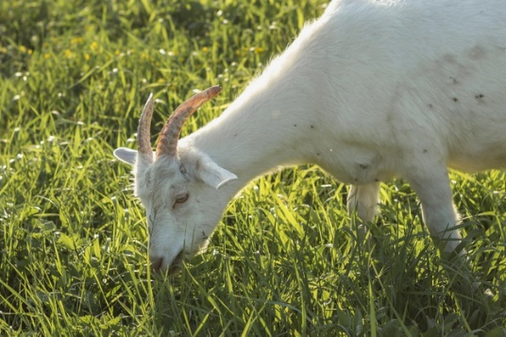 

Class #2: Motor vehicles

Class #2: Motor vehicles

States: Behaviors:

1. Number of wheels 1. Accelerate

2. Brands 2. Decelerate

3. Colors 3. Switch on engine

4. Switch off engine

Instance #2: Motorcycle

States:

1. Number of wheels: 2

2. Brands: Honda

3. Color: Black

Instance #1: Car

States:

1. Number of wheels: 4

2. Brands: BMW

3. Color: Silver

 

Class #3: Fruits

Class #3: Fruits

States: Behaviors:

1. Color 1. Can be consumed

2. Number of seeds: 2. Can extract juice

3. Taste

Instance #2: Lemon

States:

1. Color: Green

2. Number of seeds: Many

3. Taste: Sour

Instance #1: Mango

States:

1. Color: Yellow

2. Number of seeds: One

3. Taste: Sweet

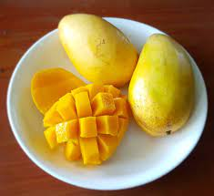 Class #4: Person

Class #4: Person

States: Behaviors:

1. Name 1. Eat

2. Nationality 2. Walk

3. Age 3. Breath

4. Occupation 4. Excrete waste

Instance #1

States:

1. Name: Adam

2. Nationality: United States

3. Age: 24

4. Occupation: Software Engineer

Instance #2

States:

1. Name: Ali

2. Nationality: Malaysia

3. Age: 20

4. Occupation: University Student

Class #5: Laptop

Class #5: Desktop

States: Behaviors:

1. Desktop Brand 1. Switch on power

2. CPU Model 2. Switch off power

3. RAM 3. Receive input

4. Commence instruction

5. Produce output

Instance #2

States:

1. Desktop Brand: Asus

2. CPU Model: AMD Ryzen 4000

3. RAM: 8GB

Instance #1

States:

1. Desktop Brand: HP

2. CPU Model: Intel i5

3. RAM: 8GB